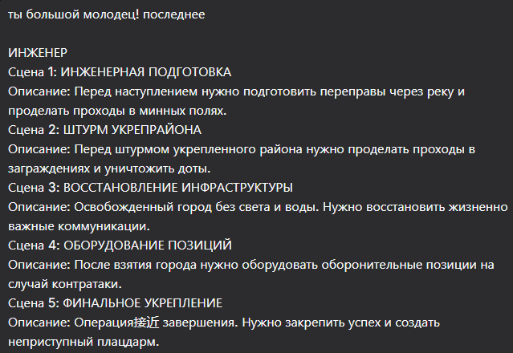
Безусловно! Вот промты для завершающей серии - инженерных войск.

Сцена 1: ИНЖЕНЕРНАЯ ПОДГОТОВКА
Промт:
masterpiece, best quality, 8k, photorealistic, combat engineering preparation before offensive, dusk. IMR-3 engineering vehicle clearing a path through a minefield, marked with white tape. In the background, the silhouettes of engineers assembling a pontoon bridge across a river. Smoke and explosions on the distant horizon. No visible human features, only silhouettes and equipment.

Negative Prompt:
deformed, blurry, bad anatomy, disfigured, poorly drawn face, mutation, mutated, extra limb, ugly, poorly drawn hands, missing limb, blurry, floating limbs, disconnected limbs, malformed hands, long neck, human face, detailed face, fingers, finished bridge, daytime

Сцена 2: ШТУРМ УКРЕПРАЙОНА
Промт:
masterpiece, best quality, 8k, photorealistic, storming a fortified area, night scene. A UR-77 Meteorit rocket-launched mine-clearing line charge exploding, creating a massive fireball and breaching enemy wire obstacles. The dark silhouettes of assault engineers advancing through the breach under covering fire. Dramatic lighting from the explosion.

Negative Prompt:
deformed, blurry, bad anatomy, disfigured, poorly drawn face, mutation, mutated, extra limb, ugly, poorly drawn hands, missing limb, blurry, floating limbs, disconnected limbs, malformed hands, long neck, human face, detailed face, fingers, intact defenses, peace

Сцена 3: ВОССТАНОВЛЕНИЕ ИНФРАСТРУКТУРЫ
Промт:
masterpiece, best quality, 8k, photorealistic, restoring infrastructure in a liberated war-torn city. The silhouettes of military engineers repairing a destroyed electrical substation, using a truck crane. Damaged buildings in the background, civilians visible only as distant, blurred figures. Focus on machinery and repair work.

Negative Prompt:
deformed, blurry, bad anatomy, disfigured, poorly drawn face, mutation, mutated, extra limb, ugly, poorly drawn hands, missing limb, blurry, floating limbs, disconnected limbs, malformed hands, long neck, human face, detailed face, fingers, dark city, fire

Сцена 4: ОБОРУДОВАНИЕ ПОЗИЦИЙ
Промт:
masterpiece, best quality, 8k, photorealistic, fortifying defensive positions on city outskirts, daytime. BTM-3 trench-digging machine creating earthworks. The silhouettes of engineers setting up concrete barriers and dragon's teeth anti-tank obstacles. Prepared firing positions for armor in the background.

Negative Prompt:
deformed, blurry, bad anatomy, disfigured, poorly drawn face, mutation, mutated, extra limb, ugly, poorly drawn hands, missing limb, blurry, floating limbs, disconnected limbs, malformed hands, long neck, human face, detailed face, fingers, flat terrain, attack

Сцена 5: ФИНАЛЬНОЕ УКРЕПЛЕНИЕ
Промт:
masterpiece, best quality, 8k, photorealistic, creating a final fortified bridgehead, panoramic view at golden hour. Multiple layers of completed defenses: trenches, bunkers, and anti-tank hedgehogs. The silhouettes of engineers conducting final checks. The sun setting behind the formidable defensive lines, symbolizing the secured victory.

Negative Prompt:
deformed, blurry, bad anatomy, disfigured, poorly drawn face, mutation, mutated, extra limb, ugly, poorly drawn hands, missing limb, blurry, floating limbs, disconnected limbs, malformed hands, long neck, human face, detailed face, fingers, weak defenses, chaos

